Final Report

On

**Fruit Quality Detection**



School of Computer Science and Engineering

**Lovely Professional University.**

**Phagwara, Punjab (India).**

INT 404 – ARTIFICIAL INTELLIGENCE

Submitted to: Dipen Saini

|  |  |  |  |  |
| --- | --- | --- | --- | --- |
| Roll No | Registration No | Name of the Student | Marks | Signature |
| 31 | 11806769 | BC Vijaykanth Reddy |  |  |
| 62 | 11816004 | Rahedujjaman Udoy |  |  |
| 65 | 11805284 | Ajith Reddy |  |  |

GitHub link:

https://github.com/vijaywar/Fruit-Quality-detection

1

APPENDIX 2

**Student Declaration**

This is to declare that this report has been written by me/us. No part of the report is copied from other sources. All information included from other sources have been duly acknowledged. I/We aver that if any part of the report is found to be copied, I/we are shall take full responsibility for it.

|  |  |  |
| --- | --- | --- |
| Roll No | Registration No | Name of the Student |
| 31 | 11806769 | BC Vijaykanth Reddy |
| 62 | 11816004 | Rahedujjaman Udoy |
| 65 | 11805284 | Ajith Reddy |

2

APPENDIX 3

TABLE OF CONTENTS

TITLE PAGE NO.

Introduction ................ 4

Code............................................................................ 5-6

Working Procedure. ............................................. 6

Output Results ........................................................... 7-9

Libraries Used ............................................................ 9-10

3

Introduction

Fruit Quality detection based on the colour and shape of the object. The fruits are detected using cvlib.object_detection from this detection fruits are separated and then it is further processed to get data in pixel level. Here the pixels are matched with the sum R,G,B is less than 100 then it is considered it has more spots and black spots and it is marked as spoiled fruit.

Using cv2 text is printed on the image in the coordinates acquired from the cv.detect_common_objects(). Each image is scanned multiple times to find fruits if there are any multiple fruits in the same image and each fruit is cropped and separately analysed to find the quality.

4

Code:

import cv2

import matplotlib.pyplot as plt

import cvlib as cv

from cvlib.object_detection import draw_bbox

from PIL import Image

import tkinter

import tkinter.filedialog

import os

root = tkinter.Tk()

root.withdraw() #use to hide tkinter window

currdir = os.getcwd()

tempdir =tkinter.filedialog.askopenfilename(parent=root, initialdir=currdir, title='Please select a Fruits Image')

if len(tempdir) > 0:

print ("You chose %s" % tempdir)

print("Please wait Processing....")

iml = cv2.imread(tempdir,cv2.IMREAD_COLOR)

plt.imshow(iml)

bbox, label, conf = cv.detect_common_objects(iml)

k=0

ab=[]

for i in label:

if i in ['apple','banana','mango','grapes']:

pass

else:

ab.append(k)

print('Removed {}'%i)

k+=1

for i in range(len(ab)):

label.pop(ab(len(ab)-i-1));

bbox.pop(ab(len(ab)-i-1));

conf.pop(ab(len(ab)-i-1));

out=Image.open(tempdir)

k=0

for i in bbox:

til=out.crop(i)

#til=cv2.cvtColor(til,cv2.IMREAD_COLOR)

pixels = til.getdata() # get the pixels as a flattened sequence

black_thresh = 100

nblack = 0

for pixel in pixels:

if sum(pixel) < black_thresh: 5

nblack += 1

n = len(pixels)

print(nblack)

if (nblack / float(n)) > 0.05:

print("mostly spoiled")

cv2.putText(iml,"Mostly Spoiled!!!", (i[0]+40,i[1]+40), cv2.FONT_HERSHEY_SIMPLEX, 0.6,(50,50,255),2,cv2.LINE_AA)

else:

cv2.putText(iml,"Good Quality!!!", (i[0]+40,i[1]+40), cv2.FONT_HERSHEY_SIMPLEX, 0.6,(50,255,0),2,cv2.LINE_AA)

til.show()

k+=1

print("Please wait dispalying completely analysed labeled image")

cv2.imshow('image',iml)

#output_image = draw_bbox(iml, bbox, label, conf)

print(label)

print(conf)

print(bbox)

#plt.imshow(output_image)

plt.show()

Working Procedure:

First this program asks user to select a image of fruit a simple image. Then the program detects all common objects and fruits and then separates the fruits from the collection and It gets the data of each pixel by cropping the fruits separately. The object is compared with colour of a good quality and a bad quality fruit and predicated the quality of the choose fruit.

6

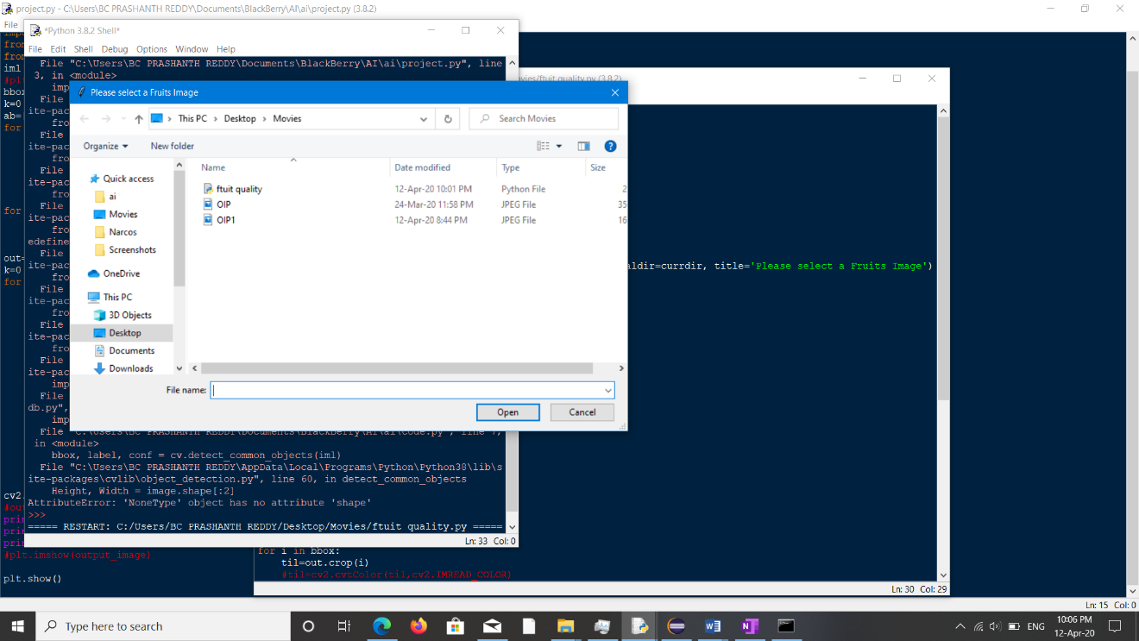

Good Quality Fruits are labelled as Good with Green colour and bad are marked as spoiled in red.

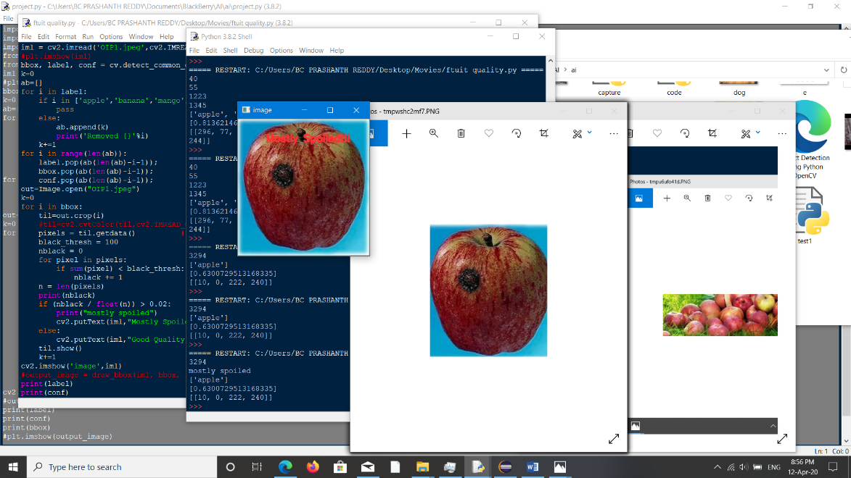

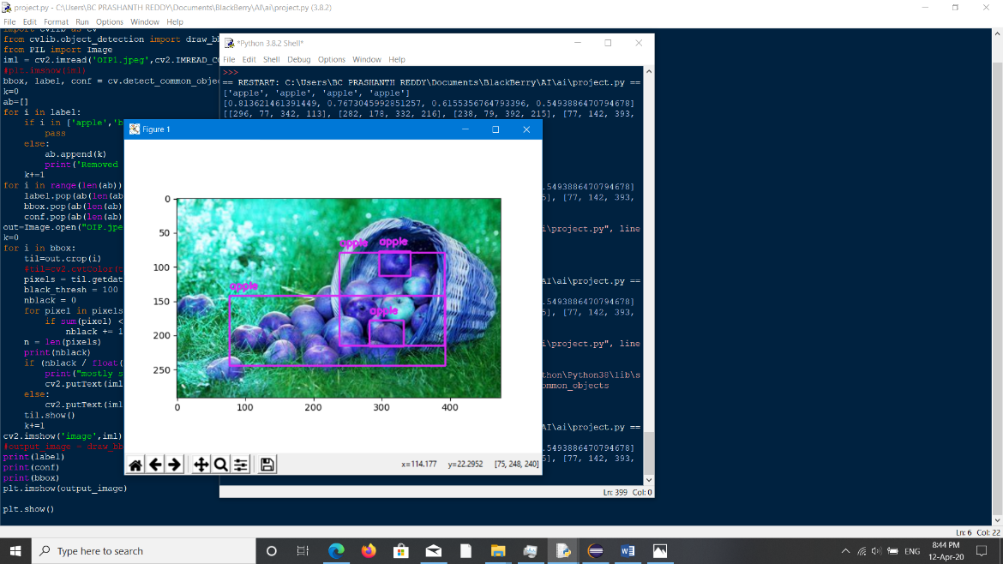

Fruits are detected and coped to individual fruits and analysed to get the quality of each fruit.

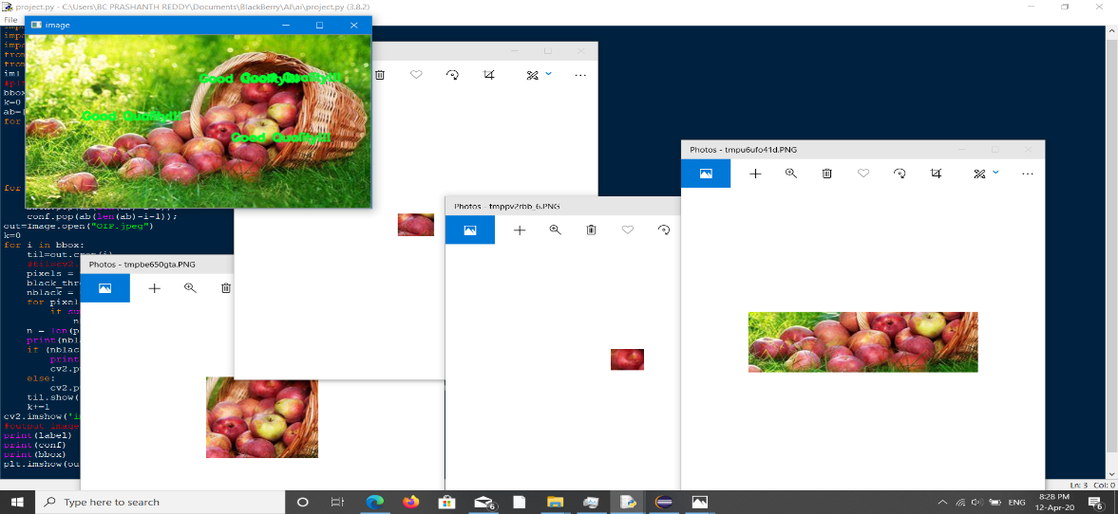7

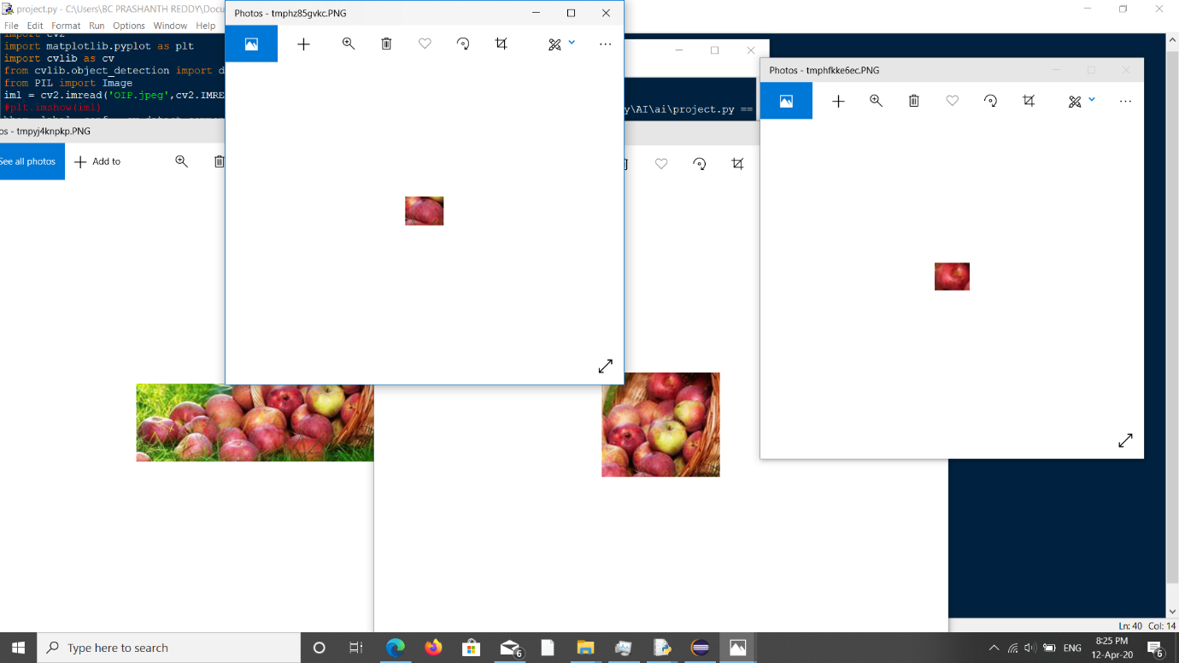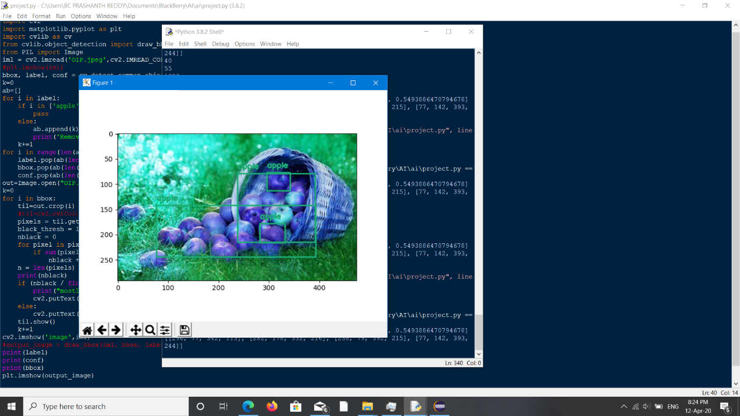

**1.cv2**

Used to import images and label and display images.

**2.cvlib as cv**

Used to crop images and analyse fruits separately.

9

**3.cvlib.object_detection import draw_bbox**

Used to detect common objects and their coordinates and name of the object.

**4.PIL import Image**

Used to analyse colour of the fruit and shape and size.

**5.tkinter**

Used to display GUI to select image in the program beginning.

**6.tkinter.filedialog**

Used to create a dialogue box that asks for select image.

**7.os**

Used to get file path when selected in the GUI.

10